|  |  |  |
| --- | --- | --- |
|  | Available online at www.sciencedirect.com |  |
|  |
| AASRI Procedia 3 ( 2012 ) 630 – 635 |

2012 AASRI Conference on Modeling, Identification and Control

Effects of Spray Angle on Spray Cooling of Extruded Aluminum Alloy Plate

Haibo Yang*, Xinchun Cao, Xuewen Sun

|  |  |  |
| --- | --- | --- |
| *School of Mechanical Engineering, University of Science and Technology Beijing* |  | *Beijing, 100083,China* |

**Abstract**

Spray cooling technology relying on phase-change mechanism has a notable ability to remove high heat fluxes. Spray cooling can be used to transfer large amounts of energy through the latent heat of evaporation. Heat transfer rates much higher than can be attained in pool boiling are possible with spray cooling since the vapor can be removed from the surface more easily. Therefore, spray cooling has a number of applications in the various fields such as continuous casting process, electronics thermal control and metal quenching process which require a high flux cooling technique [1-3]. One important area which would benefit from spray cooling to improve heat removal is press quenching of extruded aluminum alloy plate.

© 2012 Published by Elsevier B.V. Selection and/or peer revi[ew under responsibi](http://creativecommons.org/licenses/by-nc-nd/3.0/)lity of American Applied Science Research Institute Selection and/or peer review under responsibility of American Applied Science Research Institute

*Keywords*: spray cooling, spray angle, heat transfer coefficient, aluminum alloy plate, equivalent stress;

|  |  |
| --- | --- |
| **1.** | **Introduction** |

Heat transfer in spray cooling has been studied extensively throughout the world. Shaojun Zhang et al [4] studied the effects of spray distance and high-temperature steel plate’s surface temperature on heat transfer coefficient in spray cooling. Eric A. Silk et al [5] investigated the effects of surface roughness and spray inclination angle on spray cooling.

* Haibo Yang. Tel: 13661173839.   
*E-mail address:* yhb@ustb.edu.cn.

2212-6716 © 2012 The Authors. Published by Elsevier B.V. Open access under [CC BY-NC-ND license.](http://creativecommons.org/licenses/by-nc-nd/3.0/) Selection and/or peer review under responsibility of American Applied Science Research Institute doi: 10.1016/j.aasri.2012.11.100

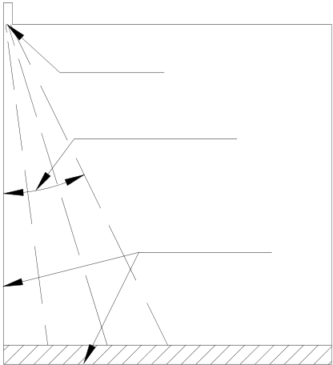

*Haibo Yang et al. / AASRI Procedia 3 ( 2012 ) 630 – 635*  631

In the past few years, studies [6-8] on the spray angle are focused on the spray angle itself and the coefficients of discharge and the spray cone angle, fruitful results were obtained by both experimental and numerical research. However, progress in the research of effects of spray angle on spray cooling has been very slow, especially in the field of metal press quenching. The analysis of the effects of spray angle on heat transfer is much more difficult and the direct numerical simulation is the best choice for theoretical study.

This paper attempts to make some numerical investigations on the effects of spray angle on spray cooling of extruded aluminum alloy plate to look for an optimal range of spray angle value that can improve the cooling performance. A commercial FVM code, Fluent, will be employed to calculate the temperature distribution within the cooled aluminum plate. The corresponding stress distribution is obtained with the help of MSC.Marc software.

**2.**  **Model Building**

The cooling target is 300 mm × 10 mm section aluminum alloy plate, Fig 1 shows the simplified spray cooling model for analysis with nozzle arrangement. The pressure boundary condition at inlet and outlet is P = 101325 Pa. For the surface, no slip boundary condition is considered. SIMPLE algorithm is adopted as the pressure-velocity coupling solver. It is clear from the 2-D mesh model shown in Fig 2 that the mesh around the outlet of nozzle along the spray axis is locally fined to improve the computation resolution.

The spray operating pressure is 0.3 MPa, the orifice diameter of spray nozzle is 2 mm, the spray angles varied between 10º and 110º, the spray distance from the plate surface is 150 mm, the cooling time is 10 s, the gravity is neglected in the model.

The aluminum plate is assumed of uniform temperature distribution when it is extruded from the extruding machine. Therefore, the initial temperature distribution of the plate is set uniform, the temperature value is set 793 K. The material property is 6061 aluminum alloy.

nozzle

spray half angle

symmetry line

Fig.1. schematic diagram of simplified model for analysis

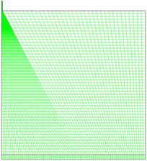

Fig.2. meshed model for analysis

632  *Haibo Yang et al. / AASRI Procedia 3 ( 2012 ) 630 – 635*

**3.**  **Simulation Results And Analysis**

The distribution of heat transfer coefficient on top surface at different spray angle is described in Fig 3, which indicates that the highest heat transfer coefficient is at the spray stagnation point (located at the central point of top surface) in all cases. With the distance from the stagnation point increasing, the heat transfer coefficient is on a decrease on the whole. From the Fig 4, it can be observed that the increase of cooling efficiency and cooling uniformity can be improved under an optimal range of spray angle, in this paper, the optimal range of spray angle is from 70º to 90º.

Heat transfer coefficient is a very important factor affecting the temperature change, therefore, it is can be seen from the Fig 5 and Fig 6 that the bigger the spray angle is, the more uniform the surface temperature distribution becomes, and when the spray angle is about 90º, the mean surface temperature reaches the maximum value. So increasing the spray angle can make contribution to cooling uniformity to certain extent, and cooling efficiency attained the highest at spray angle ranging from 70º to 90º.

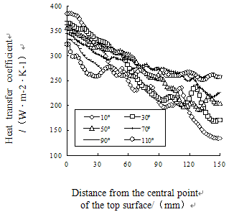

Fig.3. surface heat transfer coefficient distribution at different spray angles

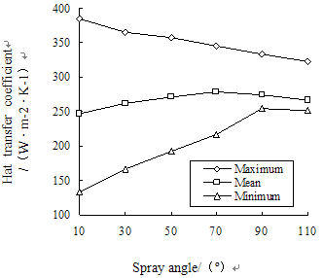

|  |  |
| --- | --- |
| Fig.4. | relationship between spray angles and surface heat transfer coefficient distribution |

*Haibo Yang et al. / AASRI Procedia 3 ( 2012 ) 630 – 635*  633

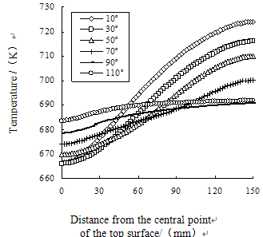

Fig.5. surface temperature distribution at different spray angles

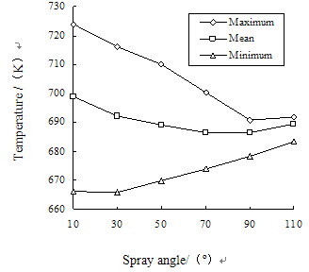

Fig.6. relationship between spray angles and surface temperature distribution

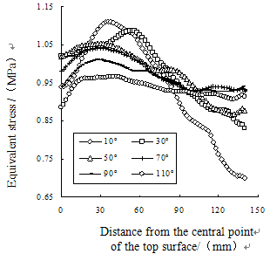

|  |  |
| --- | --- |
| Fig.7. | surface equivalent stress distribution at different spray angle(0~140mm from the cental point) |

634  *Haibo Yang et al. / AASRI Procedia 3 ( 2012 ) 630 – 635*

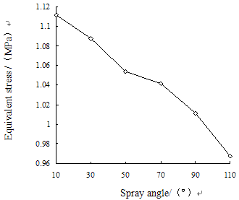

Fig.8. relationship between spray angles and maximum surface equivalent stress

From Fig 7 and Fig 8, which show the equivalent stress distribution and maximum surface equivalent stress on the top surface at different spray angles, it can be found that increasing spray angle can remarkably better the uniformity of the surface equivalent stress distribution and help lower the maximum surface equivalent stress, it is meaningful in keeping high quality and satisfactory shape of the product.

**4.**  **Conclusion**

A numerical study of spray cooling of extruded aluminum alloy plate with an emphasis on spray angle effects on cooling performance has been presented. The analysis for the cooling process is a combination of FEM and FVM. The results show that increasing spray angle contributes to improving uniformity of surface temperature distribution, surface equivalent stress distribution and reduction of maximum surface equivalent stress obviously, and the spray cooling will be performed with higher thermal efficiency in a certain range of spray angle, the optimal range of spray angle is from 70ºto 90º in this paper.

**Acknowledgements**

This research was supported by the cooperation program (No.2009B090300063) in industry, education and research of Guangdong province and Ministry of Education of P.R.China.

**References**

[1] Silk E A.Investigation of enhanced surface spray cooling. College Park: University of Maryland(2006) . [2] R. H. Chen, L. C. Chow, J. E. Navedo. “Effects of spray characteristics on critical heat flux in subcooled water spray cooling,” International Journal of Heat and Mass Transfer, 45, 4033-4043(2002).

[3] Navedo J E . Parametric effects of spray characteristics on spray cooling heat transfer. Orlando, Florida: University of Central Florida(2000).

[4] Shaojun Zhang, Zhirui Bian, Chunyan Yang, Yanhua Shan . “Effects of surface-to-nozzle distance and high-temperature plate’s surface temperature on spray cooling heat transfer coefficient.” Journal of University of Science and Technology Beijing, 1, 67-69(2007).

[5] Eric A. Silk, Jungho Kim, Ken Kiger . “Spray cooling of enhanced surfaces: Impact of structured surface

*Haibo Yang et al. / AASRI Procedia 3 ( 2012 ) 630 – 635*  635

geometry and spray axis inclination,” International Journal of Heat and Mass Transfer, 49(25-26), 4910-4920(2006).

[6] M. R. Halder, S. K. Dash, S. K. Som. “A numerical and experimental investigation on the coefficients of discharge and the spray cone angle of a solid cone swirl nozzle,” Experimental Thermal and Fluid Science, 28(4), 297-305(2004).

[7] A. Datta, S. K. Som. “Numerical prediction of air core diameter, coefficient of discharge and spray cone angle of a swirl spray pressure nozzle,” International Journal of Heat and Fluid Flow, 21(4), 412-419(2000).

[8] Q. Zhou, P. C. H. Miller, P. J. Walklate, N. H. Thomas . “Prediction of Spray Angle from Flat Fan Nozzles,” Journal of Agricultural Engineering Research, 64, 139-148(1996).